**What are the high level I/O functions in C language?**

I/O refers to the input - output functions in C language.

**High level I/O**

* These are easily understood by human beings
* The advantage is portability.

**Low level I/O**

* These are easily understood by computer.
* The advantage is that execution time is less.
* The disadvantage is that Non portability.

**High level I/O Functions**

The high level input - output (I/O) functions are explained below −

| **Function** | **Description** |
| --- | --- |
| fprintf ( ) | write data into a file |
| fscanf ( ) | read data from a file |
| putc ( )/ fputc() | write a character into a file |
| getc ( ) /fgetc() | read a character from a file |
| putw ( ) | write a number into a file |
| getw ( ) | read number from a file |
| fputs ( ) | write a string into a file |
| fgets ( ) | read a string from a file |
| fread() | read an entire record from a file |
| fwrite() | write an entire record into a file |

**fprintf ( ) & fscanf ( ) functions**

* **fprintf ( )**

The syntax is as follows −

fprintf (file pointer, " control string”, variable list)

For example,

FILE *fp;

fprintf (fp, "%d%c”, a,b);

* **fscanf ( )**

The syntax is as follows −

fscanf(file pointer, "control string”, & variable list);

For example,

FILE *fp;

fscanf (fp, "%d%c”, &a,&b);

**putc( ) and getc( ) functions**

* **putc ( )**

It is used for writing a character into a file.

The syntax is as follows −

putc (char ch, FILE *fp);

For example,

FILE *fp;

char ch;

putc(ch, fp);

* **get c ( )**

It is used to read a character from file.

The syntax is as follows −

char getc (FILE *fp);

For example,

FILE *fp;

char ch;

ch = getc(fp);

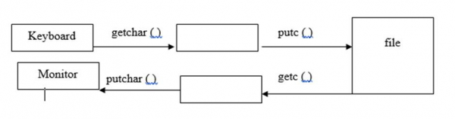

**putw ( ) and getw ( ) functions**

* **putw( )**

It is used for writing a number into file.

The syntax is as follows −

putw (int num, FILE *fp);

For example,

FILE *fp;

int num;

putw(num, fp);

* **getw ( )**

It is used for reading a number from a file.

The syntax is as follows −

int getw (FILE *fp);

For example,

FILE *fp;

int num;

num = getw(fp);

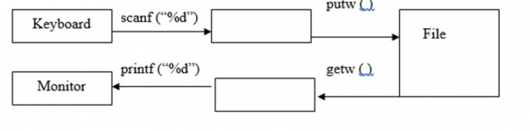

**fput c ( ) and fgetc ( ) functions**

* **fputc( )**

It is used for writing a character in to a file.

The syntax is as follows −

fputc (char ch, FILE *fp);

For example,

FILE *fp;

char ch;

fputc (ch.fp);

* **fgetc( )**

It is used for reading a character from a file.

The syntax is as follows −

fputc (char ch, FILE *fp);

For example,

FILE *fp;

char ch;

ch = fgetc(fp);

**fgets ( ) and fputs ( ) functions**

* **fgets ( )**

It is used for reading a string from a file.

The syntax is as follows

fgets (string variable, No. of characters, File pointer);

For example,

FILE *fp;

char str [30];

fgets (str,30,fp);

* **fputs ( )**

It is used for writing a string into a file.

The syntax is as follows −

fputs (string variable, file pointer);

For example,

FILE *fp;

char str[30];

fputs (str,fp);

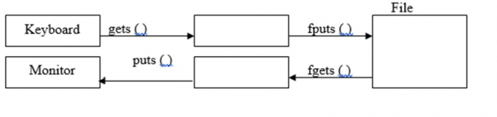

**fread ( ) and fwrite ( ) functions**

* **fread ( )**

It is used for reading entire record at a time.

The syntax is as follows −

fread( & structure variable, size of (structure variable), no of records, file pointer);

For example,

struct emp{

   int eno;

   char ename [30];

   float sal;

} e;

FILE *fp;

fread (&e, sizeof (e), 1, fp);

* **fwrite ( )**

It is used for writing an entire record at a time.

The syntax is as follows −

fwrite( & structure variable , size of structure variable, no of records, file pointer);

For example,

struct emp{

   int eno:

   char ename [30];

   float sal;

} e;

FILE *fp;

fwrite (&e, sizeof(e), 1, fp);

**Example Program**

Following is the C program for storing numbers from 1 to 10 and to print the same −

//Program for storing no’s from 1 to 10 and print the same

#include<stdio.h>

int main( ){

   FILE *fp;

   int i;

   fp = fopen ("num.txt", "w");

   for (i =1; i<= 10; i++){

      putw (i, fp);

   }

   fclose (fp);

   fp =fopen ("num.txt", "r");

   printf ("file content is");

   for (i =1; i<= 10; i++){

      i= getw(fp);

      printf ("%d",i);

   }

   fclose (fp);

   return 0;

}

**Output**

When the above program is executed, it produces the following result −

file content is12345678910

Given below is another C program for storing the details of 5 students into a file and print the same by using fread ( ) and fwrite ( ) −

**Example**

#include<stdio.h>

struct student{

   int sno;

   char sname [30];

   float marks;

   char temp;

};

main ( ){

   struct student s[60];

   int i;

   FILE *fp;

   fp = fopen ("student1.txt", "w");

   for (i=0; i<2; i++){

      printf ("enter details of student %d\n", i+1);

      printf("student number:");

      scanf("%d",&s[i].sno);

      scanf("%c",&s[i].temp);

      printf("student name:");

      gets(s[i].sname);

      printf("student marks:");

      scanf("%f",&s[i].marks);

      fwrite(&s[i], sizeof(s[i]),1,fp);

   }

   fclose (fp);

   fp = fopen ("student1.txt", "r");

   for (i=0; i<2; i++){

      printf ("details of student %d are\n", i+1);

      fread (&s[i], sizeof (s[i]) ,1,fp);

      printf("student number = %d\n", s[i]. sno);

      printf("student name = %s\n", s[i]. sname);

      printf("marks = %f\n", s[i]. marks);

   }

   fclose(fp);

   getch( );

}

**Output**

When the above program is executed, it produces the following result −

enter details of student 1

student number:1

student name:bhanu

student marks:50

enter details of student 2

student number:2

student name:priya

student marks:69

details of student 1 are

student number = 1

student name = bhanu

marks = 50.000000

details of student 2 are

student number = 2

student name = priya

marks = 69.000000